1. Discuss briefly the consequences of Bhopal gas tragedy.

Thousands of people had died by the following morning. Primary causes of deaths were [choking](https://en.wikipedia.org/wiki/Choking), reflexogenic [circulatory collapse](https://en.wikipedia.org/wiki/Circulatory_collapse) and [pulmonary oedema](https://en.wikipedia.org/wiki/Pulmonary_oedema). Findings during [autopsies](https://en.wikipedia.org/wiki/Autopsy) revealed changes not only in the lungs but also [cerebral oedema](https://en.wikipedia.org/wiki/Cerebral_oedema), [tubular necrosis](https://en.wikipedia.org/wiki/Tubular_necrosis) of the kidneys, [fatty degeneration of the liver](https://en.wikipedia.org/wiki/Fatty_liver) and necrotising [enteritis](https://en.wikipedia.org/wiki/Enteritis).[[30]](https://en.wikipedia.org/wiki/Bhopal_disaster#cite_note-Sriramachari-30) The [stillbirth](https://en.wikipedia.org/wiki/Stillbirth) rate increased by up to 300% and the [neonatal mortality](https://en.wikipedia.org/wiki/Perinatal_mortality#Neonatal_mortality) rate by around 200%.[[5]](https://en.wikipedia.org/wiki/Bhopal_disaster#cite_note-Eckerman2005-5) The individuals who did not die were exposed to cancers, blindness, loss of livelihood, and financial strain

2. Differentiate between renewable and non-renewable natural resources.

|  |  |  |
| --- | --- | --- |
| **Parameters** | **Renewable Resources** | **Non-Renewable Resources** |
| **Depletion or exhaustion** | There is no depletion in them with continuous consumption. | These get depleted with continuous consumption. |
| **Examples** | Sunlight, wind, water, vegetation, etc. | Mineral ores, fossil fuels such as coal and petroleum. |
| **Impact on the environment** | These emit low carbon and thus have a low [carbon footprint](https://www.toppr.com/ask/question/carbon-footprint-is-the-amount-of-carbon-dioxide-released-into-the-atmosphere-because-of-human/). | These emit comparatively higher carbon and thus have a higher carbon footprint. |
| **Upfront cost** | The upfront cost is high. | The upfront cost is low. |
| **Infrastructure** | In order to harvest renewable energy, the cost of infrastructure is very high. | In order to harvest non-renewable resources, the cost of [infrastructure](https://www.toppr.com/ask/question/write-the-types-of-infrastructure/) is low and cost-effective. |
| **Area** | It requires a huge area for wind farms, etc. | It requires a smaller area, comparatively. |

3. What is solar energy? Enumerate the application of solar energy in modern days.

Solar energy is **the radiation from the Sun capable of producing heat, causing chemical reactions, or generating electricity**

**Residential Application**

 The solar energy is used in residential homes for heating the water with the help of solar heater.

**Transportation**

Solar energy is also used for public transportation such as trolleys, buses and light-rails.

**Pool heating**

Solar heating system can be used to heat up water in pool during cold seasons.

**Industrial Application**

Solar energy is used to power radio and TV stations. It is also used to supply power to lighthouse and warning light for aircraft.

**Remote Application**

Solar energy can be used for power generation in remotely situated places like schools, homes, clinics and buildings. Water pumps run on solar energy in remote areas.

4. What is geothermal energy? Discuss its merits and demerits

Geothermal energy is the **thermal energy generated and stored in the earth**. It is the thermal energy generated from radioactive decay and continuous heat loss from the earth's formation.

**Advantages of Geothermal Energy**

* Many buildings, sidewalks, and parking lots are heated using geothermal energy.
* Also, known as a green source of energy because it does not release hazardous greenhouse gases. Thus, it is safe for both environmental and human health.
* Geothermal energy systems can adjust to various conditions.
* One of the best advantages of geothermal energy is that cold countries use geothermal energy to heat greenhouses or heat water for irrigation.
* Iceland mostly uses geothermal energy to heat buildings and water using magma and molten rock resources.
* It is a renewable, carbon-free, and sustainable source of energy. The Earth will continuously transmit heat from its core for billions of years.

### Disadvantages of Geothermal Energy

* Geothermal energy emits sulphur dioxide and hydrogen sulphide.
* The regions that consist of geothermal plants often experience minor seismic activity.
* The power plants can also damage roadways, buildings, pipelines, and natural drainage systems.
* Land subsidence can also occur in case geothermal energy yielders fail to inject back the extracted water from the reservoir into the Earth.
* The method of drilling geothermal plants deep under the Earth proves to be dangerous for the people involved in the process that is one of the greatest disadvantages of geothermal energy.
* It is hard for developing countries to build thermal plants because of their high initial cost.
* Geothermal energy emits out at a gradual speed from the Earth's mantle.
* The construction of geothermal sites may be hazardous for the environment as the process may discharge highly toxic gases.

5. How will you get energy from biological degradable materials?

Anaerobic digestion:The is the microbial decomposition of organic waste in the absence of oxygen, producing biogas (methane) and digestate (fertilizer). Renewable energy is generated in sealed tanks in the form of biogas, which can be converted to heat or electricity.

Fermentation: The refers to the conversion of organic waste to acid or alcohol (ethanol, lactic acid, etc.) in the absence of oxygen, leaving a nutrient-rich residue. A pure culture of selected yeast strains can be used to make bioethanol, which is a clean fuel for transportation.

6. Hydrogen can be considered as a future energy fuel. Explain.

Hydrogen is considered an alternative fuel. It is due to its ability to power fuel cells in zero-emission electric vehicles, its potential for domestic production, and the fuel cell's  potential for high efficiency. In fact, a fuel cell coupled with an electric motor is two to three times more efficient than an internal combustion engine running on gasoline. Hydrogen can also serve as fuel for internal combustion engines. The energy in 2.2 pounds (1 kilogram) of hydrogen gas contains about the same as the energy in 1 gallon (6.2 pounds, 2.8 kilograms) of gasoline.

7. What is nuclear energy? Discuss its potential and utilization in India.

Nuclear energy is a form of energy released from the nucleus, the core of atoms, made up of protons and neutrons. This source of energy can be produced in two ways: fission – when nuclei of atoms split into several parts – or fusion – when nuclei fuse together.

[Nuclear power](https://en.wikipedia.org/wiki/Nuclear_power) is the fifth-largest source of [electricity in India](https://en.wikipedia.org/wiki/Electricity_in_India) after coal, gas, [hydroelectricity](https://en.wikipedia.org/wiki/Hydroelectricity) and [wind power](https://en.wikipedia.org/wiki/Wind_power). As of November 2020, [India](https://en.wikipedia.org/wiki/India) has 22 [nuclear reactors](https://en.wikipedia.org/wiki/Nuclear_reactor) in operation in 7 [nuclear power plants](https://en.wikipedia.org/wiki/Nuclear_power_plant) .with a total installed capacity of 7,380 MW.[[1]](https://en.wikipedia.org/wiki/Nuclear_power_in_India#cite_note-KudankulamComissioning-1)[[2]](https://en.wikipedia.org/wiki/Nuclear_power_in_India#cite_note-2) Nuclear power produced a total of 43 [TWh](https://en.wikipedia.org/wiki/TWh" \o "TWh) in 2020-21, contributing 3.11% of total power generation in India (1,382 TWh).[[3]](https://en.wikipedia.org/wiki/Nuclear_power_in_India#cite_note-3) 10 more reactors are under construction with a combined generation capacity of 8,000 MW.

8. Explain the use of solar energy for the purpose of:

a. Solar water heating : Solar heating & cooling (SHC) technologies collect the thermal energy from the sun and use this heat to **provide hot water, space heating, cooling, and pool heating for residential, commercial, and industrial applications**. These technologies displace the need to use electricity or natural gas

b. Solar cells : solar cell, also called photovoltaic cell, any device that **directly converts the energy of light into electrical energy through the photovoltaic effect**.

c. Solar cooker : A solar cooker is a device which uses the energy of direct sunlight to **heat, cook or pasteurize drink and other food materials**.

9. Discuss the use of bio-energy as a non-conventional renewable source of energy. Also discuss its scope and utilization in Indian context.

Bio-energy, in the form of biogas, which is derived from biomass, is expected to become one of the key energy resources for global sustainable development. Biomass is a renewable energy resource derived from the carbonaceous waste of various human and natural activities. Biomass has always been an important energy source for the country considering the benefits it offers.  It is renewable, widely available, carbon-neutral and has the potential to provide significant employment in the rural areas.  Biomass is also capable of providing firm energy.  About 32% of the total primary energy use in the country is still derived from biomass and more than 70% of the country’s population depends upon it for its energy needs.  Ministry of New and Renewable Energy has realised the potential and role of biomass energy in the Indian context and hence has initiated a number of programmes for promotion of efficient technologies for its use in various sectors of the economy to ensure derivation of maximum benefits.  For efficient utilization of biomass, bagasse based cogeneration in sugar mills and biomass power generation have been taken up under biomass power and cogeneration programme.

10. Discuss ‘hydrogen as an alternate future source of energy’.

In the future, **hydrogen will join electricity as an important energy carrier, since it can be made safely from renewable energy sources and is virtually non-polluting**. It will also be used as a fuel for 'zero-emissions' vehicles, to heat homes and offices, to produce electricity, and to fuel aircraft. Future hydrogen energy infrastructure. The hydrogen is produced through a wind electrolysis system. The hydrogen is compressed up to pipeline pressure, and then fed into a transmission pipeline. The pipeline transports the hydrogen to a compressed gas terminal where the hydrogen is loaded into compressed gas tube trailers. A truck delivers the tube trailers to a forecourt station where the hydrogen is further compressed, stored, and dispensed to fuel cell vehicles

11. What is non – renewable energy resources?

A non-renewable resource is **one that either does not regenerate or does not regenerate quickly enough to serve some human purpose in a sustainable way**. The most common examples of non-renewable resources are fossil fuels, such as coal, oil and natural gas.

12. What is Solar Energy? Discuss its merit and limitation.

Solar energy is **energy emitted from the Sun or other stars and radiated in the form of electromagnetic energy, including visible light**.

**Advantages:**

* Solar energy is a completely renewable resource which means that even when we cannot make use of the sun’s power because of night time or cloudy and stormy days, we can always rely on the sun showing up the very next day as a constant and consistent power source.
* Initial cost of solar panels and solar lighting may seem quite but in the long run it saves quite a great deal of money. It does not cost anything to harness the power of the sun. Harnessing sun’s energy is absolutely free.
* Solar energy creates absolutely no pollution. Solar cells are totally silent and non-polluting.
* Very little maintenance is required to keep solar cells running. There are no moving parts in a solar cell so, they require little or no maintenance at all, and have a long lifetime.
* Solar powered panels and products are typically extremely easy to install. Wires, cords and power sources are not needed at all, making this an easy prospect to employ.

**Disadvantages:**

* Installation of solar panels is expensive. Initial investment is high.
* Solar energy cannot be harnessed during a storm, on a cloudy day or at night. Some days you may still need to rely on other sources of energy.
* Most of the solar devices occupy large space to achieve average efficiency.
* The efficiency of solar panels is low comparative to other sources of energy. To achieve equivalent output large equipment is required.
* Geographical location and climate of a place can be a source of disadvantage of solar energy. The efficiency of the solar panels is dependent upon the amount of sunlight received.
* Air pollution and weather can also have a large effect on the efficiency of the cells.
* Do not get same efficiency on all the days and during every season as the intensity of sun’s light changes with season.

13. What are renewable resources?

 A renewable resource is **one that can be used repeatedly and does not run out because it is naturally replaced**. Examples of renewable resources include solar, wind, hydro, geothermal, and biomass energy.

14. What is biomass energy?

Biomass is **the fuel developed from organic matter waste of living organisms like plant waste, animal waste, forest waste, and municipal wastes**. In biological terms, the word biomass refers to the organic plant matter, which is converted into fuel and used as an energy source.

15. Explain the significance of biomass energy.

Biomass for energy, especially biofuels, has positive attributes that contribute to a healthy environment and economy. Biomass utilization can **reduce forest management costs, help mitigate climate change, reduce risks to life and property, and help provide a secure, competitive energy source**.

16. What are the alternative energy resources? Discuss any two of them. Differentiate between renewable & non-renewable natural resources.

**The major types of renewable energy sources are:**

* Biomass energy.
* Hydropower energy.
* Geothermal energy.
* Wind energy.
* Solar energy.

Explanation:

1. Solar energy:

Solar energy is **energy emitted from the Sun or other stars and radiated in the form of electromagnetic energy, including visible light**.

**Advantages:**

* Solar energy creates absolutely no pollution. Solar cells are totally silent and non-polluting.
* Very little maintenance is required to keep solar cells running. There are no moving parts in a solar cell so, they require little or no maintenance at all, and have a long lifetime.

**Disadvantages:**

* Installation of solar panels is expensive. Initial investment is high.
* Solar energy cannot be harnessed during a storm, on a cloudy day or at night. Some days you may still need to rely on other sources of energy.

2. Biomass energy:

Biomass is **the fuel developed from organic matter waste of living organisms like plant waste, animal waste, forest waste, and municipal wastes**. In biological terms, the word biomass refers to the organic plant matter, which is converted into fuel and used as an energy source.

| [**Advantages of Biomass Energy**](https://ecavo.com/biomass-energy-advantages-disadvantages/#Advantages) | [**Disadvantages of Biomass Energy**](https://ecavo.com/biomass-energy-advantages-disadvantages/#Disadvantages) |
| --- | --- |
| It is Renewable | It’s Not Completely Clean |
| Carbon Neutrality | High Costs In Comparison To Other Alternatives |
| Less Dependency On Fossil Fuels | Possible Deforestation |
| It Is Versatile | Space |
| Availability | It Requires Water |
| Low Cost In Comparison To Fossil Fuels | It Has Inefficiencies |

|  |  |
| --- | --- |
| **Renewable Resources** | **Non-renewable Resources** |
| **Depletion** | |
| Renewable resources cannot be depleted over time | Non-renewable resources deplete over time |
| **Sources** | |
| Renewable resources include sunlight, water, wind and also geothermal sources such as hot springs and fumaroles | Non-renewable energy includes fossil fuels such as coal and petroleum. |
| **Environmental Impact** | |
| Most renewable resources have low carbon emissions and low carbon footprint | Non-renewable energy has a comparatively higher carbon footprint and carbon emissions. |
| **Cost** | |
| The upfront cost of renewable energy is high. – For instance, Generating electricity using technologies running on renewable energy is costlier than generating it with fossil fuels | Non-renewable energy has a comparatively lower upfront cost. |
| **Infrastructure Requirements** | |
| Infrastructure for harvesting renewable energy is prohibitively expensive and not easily accessible in most countries. | Cost-effective and accessible infrastructure is available for non-renewable energy across most countries |
| **Area Requirements** | |
| Requires a large land/ offshore area, especially for wind farms and solar farms | Comparatively lower area requirements |

17. What is Tidal Energy? Discuss its merit and limitation.

Tidal energy is **power produced by the surge of ocean waters during the rise and fall of tides**. Tidal energy is a renewable source of energy.

Advantages and Disadvantages of Tidal Energy

Some advantages of tidal energy are:

* Environment-friendly
* A highly predictable energy source
* High energy density
* Operational and maintenance costs are low
* An inexhaustible source of energy

Some of the disadvantages of tidal energy are:

* High tidal power plant construction costs
* Negative influence on marine life forms
* Location limits
* The variable intensity of sea waves

18. What is Hydroelectric Energy? Discuss its merit and limitation

Hydropower, or hydroenergy, is **a form of renewable energy that uses the water stored in dams, as well as flowing in rivers to create electricity in hydropower plants**.

| Hydropower pros and cons | |
| --- | --- |
| **Pros** | **Cons** |
| Renewable | Environmental consequences |
| Low emissions | Expensive to build |
| Reliable | Drought potential |
| Safe | Limited reserves |

19. What is biogas? Discuss the fixed dome type biogas plant with its merit and demerits.

iogas is a renewable, as well as a clean, source of energy. Gas generated through biodigestion is Biogas is a renewable, as well as a clean, source of energy. Gas generated through biodigestion is non-polluting; it actually reduces greenhouse emissions. A fixed-dome plant consists of a digester with a fixed, non-movable gas holder, which sits on top of the digester. When gas production starts, the slurry is displaced into the compensation tank. Gas pressure increases with the volume of gas stored and the height difference between the slurry level in the digester and the slurry level in the compensation tank.

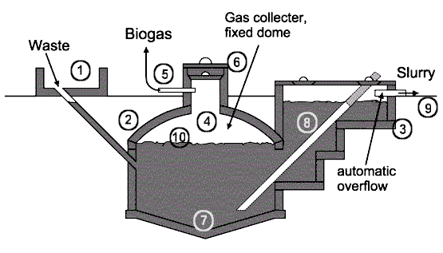

Fixed dome plant Nicarao design: 1.Mixing tank with inlet pipe and sand trap. 2.Digester. 3.Compensation and removal tank. 4.Gasholder. 5.Gaspipe. 6.Entry hatch, with gastight seal. 7.Accumulation of thick sludge. 8.Outlet pipe. 9.Reference level. 10.Supernatant scum, broken up by varying level.

### Advantage:

### Biogas is Eco-Friendly

### Biogas Generation Reduces Soil and Water Pollution

### Biogas Generation Produces Organic Fertilizer

### It’s A Simple and Low-Cost Technology That Encourages A Circular Economy

### Healthy Cooking Alternative For Developing Areas

### Disadvantages:

### Few Technological Advancements

### Contains Impurities

### Effect of Temperature on Biogas Production

### Less Suitable For Dense Metropolitan Areas

### 20. What is Wind Energy? Discuss its merit and limitation.

### Wind power or wind energy is mostly the use of wind turbines to generate electricity. Wind power is a popular, sustainable, renewable energy source that has a much smaller impact on the environment than burning fossil fuels.

| Merit of wind energy | Demerit of wind energy |
| --- | --- |
| Renewable & clean source of energy | Intermittent |
| Low operating costs | Noise and visual pollution |
| Efficient use of land space | Some adverse environmental impact |
| Wind energy is a job creator | Wind power is remote |

### 21. Differentiate between Cell and Battery.

|  |  |
| --- | --- |
| **Difference Between Cell and Battery** | |
| Cell | Battery |
| A cell is a single unit device which converts chemical energy into electric energy. | A battery usually consists of group of cells. |
| Depending on the types of electrolytes used, a cell is either reserve, wet or dry types. Cell also includes  molten salt type. | A battery is either a primary battery or a secondary battery meaning it is rechargeable or non-chargeable. |
| A cell is usually light and compact as it has a single unit. | Battery normally consists of several cells thus giving it a bigger size and is bulky. |
| A cell supplies power for a shorter period of time. | A battery can supply power for long durations. |
| A cell is used mostly for lighter tasks  which requires less energy. It is used in clocks, lamp, etc. | A battery is mostly used for heavy-duty tasks. It is used in automobiles, inverter, etc. |
| Cells are usually cheap | Batteries are much costlier. |

22. Differentiate between Primary battery and Secondary battery.

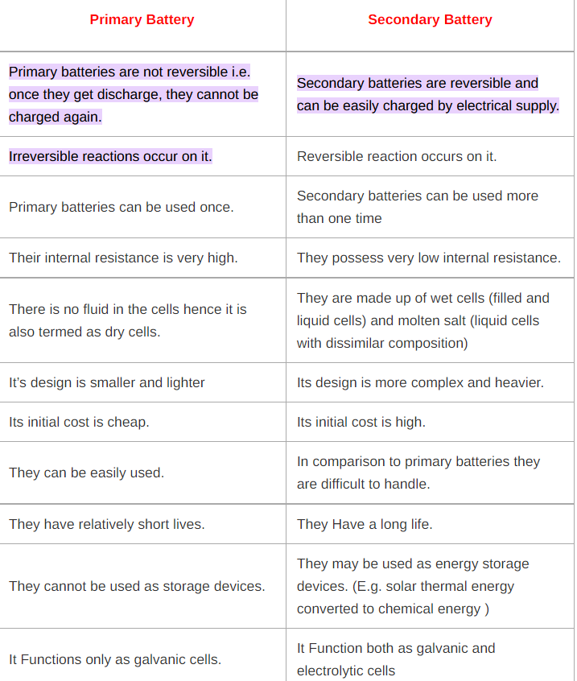

23. Define the term Battery. Classify battery based on their applications.

A Battery is a chemical device that stores electrical energy in the form of chemicals and by means of electrochemical reaction, it converts the stored chemical energy into direct current (DC) electric energy.

|  |  |  |
| --- | --- | --- |
| **Battery Type** | **Characteristics** | **Applications** |
| Zinc – Carbon | Common, low cost, variety of sizes | Radios, toys, instruments |
| Magnesium (Mg/MnO2) | High capacity, long shelf life | Military and aircraft Radios |
| Mercury (Zn/HgO) | Very high capacity, long shelf life | Medical (hearing aids, pacemakers), photography |
| Alkaline (Zn/Alkaline/MnO2) | Very popular, moderate cost, high performance | Most popular primary batteries |
| Silver/Zinc (Zn/Ag2O) | Highest capacity, costly, flat discharge | Hearing aids, photography, pagers |
| Lithium/Soluble Cathode | High energy density, good performance, wide temp range | Wide range of applications with capacity between 1 – 10,000 Ah |
| Lithium/Solid Cathode | High energy density, low temp performance, long shelf life | Replacement for button and cylindrical cells |
| Lithium/Solid Electrolyte | Low power, extremely long shelf life | Memory circuits, medical electronics |

24. What is primary cell? Discuss the construction of Lechlanche cell with its cell reactions and diagram.

A **primary** **cell** **is** a battery (a galvanic **cell**) that is designed to be used once and discarded, and not recharged with electricity and reused like a secondary **cell** ( rechargeable battery ). In general, the electrochemical reaction occurring in the **cell** **is** not reversible

Leclanche cell is a primary cell, handy for sporadic use, with positive anode of zinc encompassed by a mixture of manganese dioxide and powdered carbon in a pot, which is porous. The pot and the negative zinc terminal remained in a container holding ammonium chloride solution. The electromotive force (emf) is nearly 1 -4 volt.

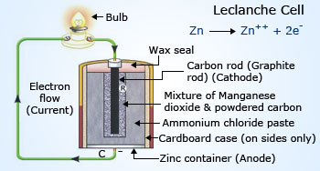

25. Discuss the construction of mercury button cell with its cell reactions and diagram.

A mercury battery (also called mercuric oxide battery, mercury cell, button cell, or Ruben-Mallory) is **a non-rechargeable electrochemical battery, a primary cell**. Mercury batteries use a reaction between mercuric oxide and zinc electrodes in an alkaline electrolyte.

ercury oxide cells are constructed **with a zinc anode, a mercury oxide cathode, and potassium hydroxide or sodium hydroxide as the electrolyte**. Since mercuric oxide is a non-conductor, some graphite is mixed with it. This helps prevent the collection of mercury into large droplets.

The overall reaction for the battery:

Zn + HgO → ZnO + Hg

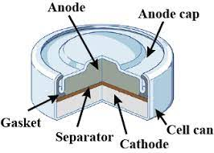

26. Discuss the construction of silver button cell with its cell reactions and diagram.

A **silver-oxide battery** [(IEC code: S)](https://en.wikipedia.org/wiki/Battery_nomenclature) is a [primary cell](https://en.wikipedia.org/wiki/Primary_cell) using silver oxide as the cathode material and zinc for the anode. These cells maintain a nearly constant nominal voltage during discharge until fully depleted.[[2]](https://en.wikipedia.org/wiki/Silver-oxide_battery#cite_note-2) They are available in small sizes as [button cells](https://en.wikipedia.org/wiki/Button_cell), where the amount of silver used is minimal and not a prohibitively expensive contributor to the overall product cost.

Overall reaction (anhydrous form):



{\displaystyle {\ce {Zn + Ag2O ->[{\ce {KOH/NaOH}}] ZnO + 2Ag (v)}}}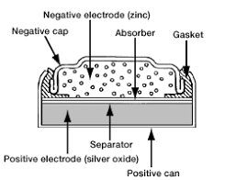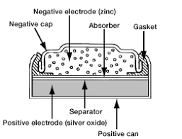

27. What is secondary cell? Discuss the construction of Lead storage cell with its cell reactions and diagram

A rechargeable electric cell that converts chemical energy into electrical energy by a reversible chemical reaction.

The various parts of the lead acid battery are:

1. Container – The container of the lead acid battery is made of glass, lead lined wood, ebonite, the hard rubber of bituminous compound, ceramic materials or moulded plastics and are seated at the top to avoid the discharge of electrolyte.

2. Plate – The plate of the lead-acid cell is of diverse design and they all consist some form of a grid which is made up of lead and the active material

3. Active Material – The material in a cell which takes active participation in a chemical reaction (absorption or evolution of electrical energy) during charging or discharging is called the active material of the cell.

4. Separators – The separators are thin sheets of non-conducting material made up of chemically treated leadwood, porous rubbers, or mats of glass fibre and are placed between the positive and negative to insulate them from each other.

5. Battery Terminals – A battery has two terminals the positive and the negative. The positive terminal with a diameter of 17.5 mm at the top is slightly larger than the negative terminal which is 16 mm in diameter.

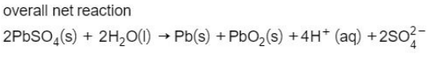

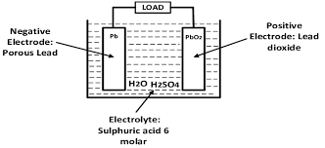

28. Explain Lead storage cell with suitable diagram. Write down the reactions involved during discharging and charging of Lead storage cell.

A lead storage battery is a secondary cell so we can charge the battery by passing current directly. So, it can be reused. Lead-acid batteries can be classified as secondary batteries. The chemical reactions that occur in secondary cells are reversible. The reactants that generate an electric current in these batteries (via [chemical reactions](https://byjus.com/chemistry/chemical-reactions/)) can be regenerated by passing current through the battery (recharging).



The discharge process is driven by the conduction of electrons from the negative plate back into the cell at the positive plate in the external circuit.

The reaction of discharging is,



The lead storage cell can be recharged **by passing a current in the reverse direction**. The half-reactions are the exact reverse of those that occur when the cell is operating as a voltaic cell.

The reaction of charging is:



29. Discuss the construction of Nickel-cadmium cell with its cell reactions and diagram.

Batteries are intended to give you the power required to run different devices, giving you the chance to carry your favorite devices with you. Today, consumers have an extensive variety of batteries to choose from, of which nickel cadmium batteries is one.

**Construction**

Nickel-cadmium batteries are also called NiCad or [rechargeable batteries](http://www.upsbatterycenter.com/blog/rechargeable-vs-single-use-batteries/). They are made of two plates of nickel oxy-hydroxide and cadmium which are leveled together and rolled in a cylindrical shape. The nickel oxy-hydroxide is the [anode](http://www.upsbatterycenter.com/blog/battery-anode/) and the cadmium, the [cathode](http://www.upsbatterycenter.com/blog/battery-cathode/). The [electrolyte](http://www.upsbatterycenter.com/blog/electrolyte-battery-2/) known as potassium hydroxide causes the build-up of an electrical charge between the anode and the [cathode](http://www.upsbatterycenter.com/blog/battery-cathode/).

The cell reaction of nickel cadmium cell:



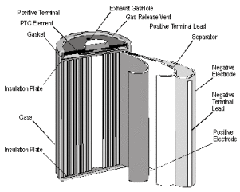

30. Differentiate between Reversible and irreversible cells.

